# Question 06

## Solution

* Take the input from user and by default input in python as string, so need to convert as integer by type casting.
* Take second number as input and make it integer
* Perform the addition on both number
* Print out on console

# Question 07

## Code

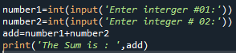

## Output

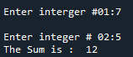

# Question 08

## Solution

In the question I want to make a program in which it takes a positive number from user and print the square of all these number from 1 to n. n is the positive number which are enter by user. If number is not positive, then not work for these number and give a message on screen.

## Code

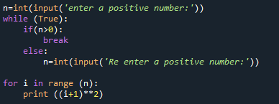

# Question 09

* Take a number from user
* Make sure the number is positive, if number is not positive than take input again until positive number is not entering.
* take a square of all these number from 1 to n by using loop. Loop repeat itself for n times.

# Question 10

## Code



## Output

